Mental or Universal Grammar

🔹 What is Mental / Universal Grammar
# Source: AI Source: Provided by: [Data Path: Persons Table -> ID Column: 1, Name_En Column: Motasem Essam] -> From: [Chatgpt (GPT-4-turbo)] on [8/3/2025]
Mental grammar (also called universal grammar) refers to the unconscious knowledge of grammar that all humans are believed to possess.
It is the internal system that allows individuals to understand and produce language—even new, unheard sentences.
This theory was introduced and popularized by Noam Chomsky as part of his broader theory of Universal Grammar (UG).

✅ Key Features of Mental/Universal Grammar:
# Source: AI Source: Provided by: [Data Path: Persons Table -> ID Column: 1, Name_En Column: Motasem Essam] -> From: [Chatgpt (GPT-4-turbo)] on [8/3/2025]
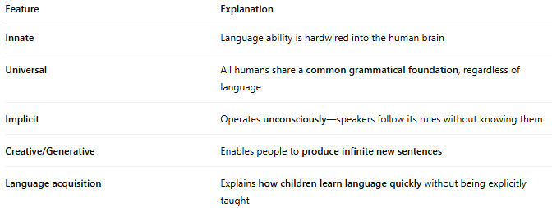
Feature | Explanation
Innate | Language ability is hardwired into the human brain
Universal | All humans share a common grammatical foundation, regardless of language
Implicit | Operates unconsciously—speakers follow its rules without knowing them
Creative/Generative | Enables people to produce infinite new sentences
Language acquisition | Explains how children learn language quickly without being explicitly taught

✅ Key Concepts in Mental/Universal Grammar:
# Source: AI Source: Provided by: [Data Path: Persons Table -> ID Column: 1, Name_En Column: Motasem Essam] -> From: [Chatgpt (GPT-4-turbo)] on [8/3/2025]
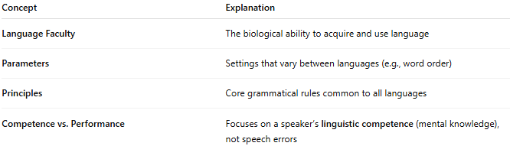
Concept | Explanation
Language Faculty | The biological ability to acquire and use language
Parameters | Settings that vary between languages (e.g., word order)
Principles | Core grammatical rules common to all languages
Competence vs. Performance | Focuses on a speaker’s linguistic competence (mental knowledge), not speech errors

✅ Examples:
# Source: AI Source: Provided by: [Data Path: Persons Table -> ID Column: 1, Name_En Column: Motasem Essam] -> From: [Chatgpt (GPT-4-turbo)] on [8/3/2025]
- A child raised in any environment automatically learns the language spoken around them, regardless of complexity.
- Even if someone has never heard the sentence:
“The dragon beside the castle has vanished into the fog,”
they can still understand and generate it because of their mental grammar.

✅ Chomsky’s Universal Grammar Hypothesis:
# Source: AI Source: Provided by: [Data Path: Persons Table -> ID Column: 1, Name_En Column: Motasem Essam] -> From: [Chatgpt (GPT-4-turbo)] on [8/3/2025]
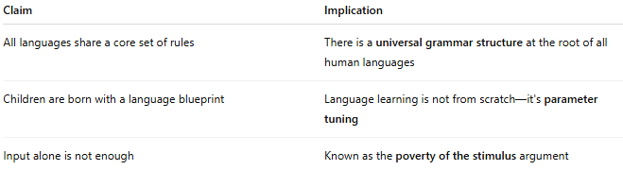
Claim | Implication
All languages share a core set of rules | There is a universal grammar structure at the root of all human languages
Children are born with a language blueprint | Language learning is not from scratch—it's parameter tuning
Input alone is not enough | Known as the poverty of the stimulus argument

✅ Mental Grammar vs. Other Types:
# Source: AI Source: Provided by: [Data Path: Persons Table -> ID Column: 1, Name_En Column: Motasem Essam] -> From: [Chatgpt (GPT-4-turbo)] on [8/3/2025]
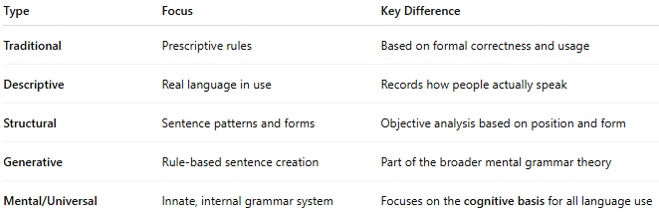
Type | Focus | Key Difference
Traditional | Prescriptive rules | Based on formal correctness and usage
Descriptive | Real language in use | Records how people actually speak
Structural | Sentence patterns and forms | Objective analysis based on position and form
Generative | Rule-based sentence creation | Part of the broader mental grammar theory
Mental/Universal | Innate, internal grammar system | Focuses on the cognitive basis for all language use

✅ Why It Matters:
# Source: AI Source: Provided by: [Data Path: Persons Table -> ID Column: 1, Name_En Column: Motasem Essam] -> From: [Chatgpt (GPT-4-turbo)] on [8/3/2025]
- Explains why and how language is uniquely human
- Central to language acquisition theories
- Foundational in cognitive science and linguistic theory
- Influences computational linguistics, AI, and neurolinguistics

📝 Summary:
# Source: AI Source: Provided by: [Data Path: Persons Table -> ID Column: 1, Name_En Column: Motasem Essam] -> From: [Chatgpt (GPT-4-turbo)] on [8/3/2025]
- Mental grammar is the internal system of rules that all speakers unconsciously follow.
- Universal grammar is the theory that this system is shared across all humans.
- It explains how children acquire language quickly and why all languages share deep similarities.
- This theory is closely tied to Noam Chomsky and forms the basis of generative linguistics.

